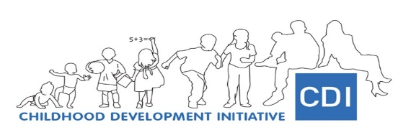

**Parent Engagement Research Project**

**Application Form: Peer Researchers**

We are delighted that you are interested in working with CDI. Thank you for taking the time to read and complete this form.

CDI need to collect some personal information from you in order to manage your application for the post of Peer Researcher. CDI will hold your records for five years but will only use your information in relation to this post. If you agree, **please check the box below**.

I consent to CDI holding my records for five years. [ ]

Please reply to the following questions and submit this form by **Monday 5th April** to the email address: [**info@cdi.ie**](mailto:info@cdi.ie)

**Name**:

**Address:**

**Email**:

**Tel:**

**We would like to know a bit about you!**

**Why are you interested in applying for this role?**

**We are interested in how many children you have and their ages:**

|  |  |
| --- | --- |
| Child: | Year of birth: |
| Child 1 |  |
| Child 2 |  |
| Child 3 |  |
|  |  |
|  |  |

**Are you involved in any activities, services or groups in the community? Please tell us about them if you are.**

**Do you have experience with online communication tools, namely Zoom, Skype, or Teams?**

No

Yes

**Do you have experience using Microsoft Word?**

No

Yes

**What type of experience do you have that may be relevant to this post?**

**What training do you have that may be relevant to this post?**

**Please indicate up to three skills that you have which can be used for this post?**

**Have you previously taken part in a research/ study?**

No

Yes, as a participant

Yes, as a researcher / part of the research team

**Have you taken part in interviews previously?**

No

Yes, as an interviewee

Yes, as an interviewer

Because the role requires you to talk with, listen to and write about local parents, we need to know how good your English is. Please indicate:

**Talking and listening:**

Native / very good

Quite good

Basic

**Writing:**

Very good

Quite good

Basic

**Case study**

Please imagine that you are going to interview a parent about this research, and that you have a set of planned questions. The goal is to collect the parents’ views on the support that he/she would like to receive to better promote his/her child’s learning and development.

**What do you think would be important to tell the parent before starting the interview?**

**During the interview, if you notice that the parent seems uncomfortable or distressed, what would you do?**

**After completing this form, please send it to** [**info@cdi.ie**](mailto:info@cdi.ie)

Thank you very much for your time and interest!

This project has received funding from the European Union’s Horizon 2020 research and innovation programme under the Marie Skłodowska-Curie grant agreement No 890925.