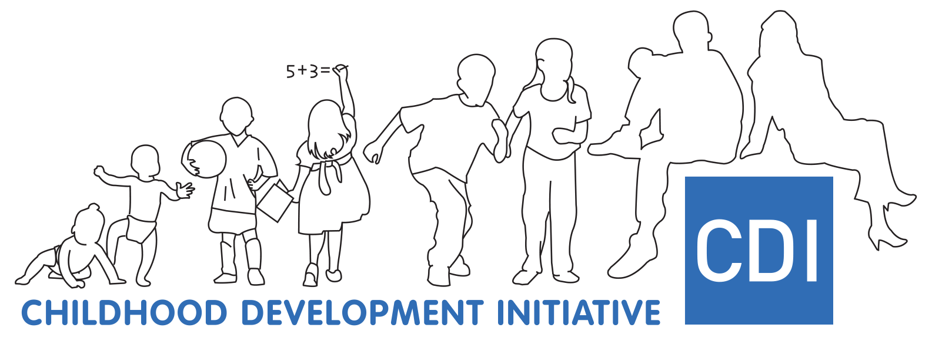

Annual Report 2019



Table of Contents

Chairpersons Foreword 2

Governance 3

CDI Programmes 4

1. ATTI 4

Level of Activity in 2019 4

Achievements and Outcomes in 2019 5

Targets for 2020 5

2. Parental Support 6

2.1. Parent Carer Facilitator 6

Level of Activity in 2019 6

Achievements and Outcomes in 2019 7

Targets for 2020 8

2.2. Families Impacted by Prison 9

Level of Activity in 2019 9

Achievements and Outcomes in 2019 9

Targets for 2020 9

3. Chit Chat 11

Level of Activity in 2019 11

Achievements and Outcomes in 2019 11

Targets for 2020 11

4. Doodle Den 13

Level of Activity in 2019 13

Achievements and Outcomes in 2019 13

Targets for 2020 13

5. Doodle Families 13

Level of Activity in 2019 14

Achievements and Outcomes in 2019 14

Targets for 2020 14

6. Dolly Parton’s Imagination Library 14

Level of Activity in 2019 14

Achievements and Outcomes in 2019 15

Targets for 2020 15

7. Restorative Practices 17

Level of Activity in 2019 17

Achievements and Outcomes in 2019 17

Targets for 2020 19

Emerging Needs 20

Level of Activity in 2019 20

Achievements and Outcomes in 2019 21

Targets for 2020 21

Planning, Monitoring and Evaluation (PM&E) 22

Achievements and Outcomes in 2019 22

Targets for 2020 23

CDI Training and Consultancy Service: 23

Level of Activity in 2019 23

Achievements and Outcomes in 2019 23

Targets for 2020 25

Conclusion 25

Acronyms 26

# Chairpersons Foreword

I am very pleased to acknowledge the significant work undertaken by the staff and Board of CDI during 2019 and welcome this report as a summary of the achievements.

The year was notable for the diversity of issues addressed, and the breadth of stakeholders with whom we engaged.

Whilst our core business of supporting the delivery of high quality, evidence informed services in Tallaght continues, we also worked hard to demonstrate the transferability of skills and approaches to other communities and target groups.

Further development of our work with families impacted by prison was progressed with dedicated funding from the ‘What Works’ grant; we harnessed the expertise and perspectives of a range of health, education and academic experts in undertaking the research on young peoples’ mental health needs, and our ongoing objectives to influence policy and practice brought us to engage with homeless agencies, disability services, parenting and early years specialists, childrens’ rights advocates, amongst many others.

I am particularly proud of CDI’s record of commissioning, supporting and disseminating high quality, responsive research which provides real and meaningful opportunity to enhance service planning and delivery.

As always, I would like to thank all the Board members at CDI, whose diligence and commitment is so vital to our work. The staff have continuously demonstrated leadership, creativity, flexibility and huge enthusiasm, and I am pleased to have this opportunity to publicly acknowledge this.

Finally, it would be impossible to read this report and not recognise the centrality of so many stakeholders, services, organisations and individuals. CDI has been fortunate in the calibre of colleagues with whom we engage, and has also worked hard to establish and develop trust and credibility in the community of Tallaght and beyond.

I am very proud to be a part of this important work.

Dr Suzanne Guerin

Chair

CDI Board of Management

# Governance

CDI takes great pride in our governance arrangements as they give us and our funder’s reassurance that our approaches, spending and strategy maximise the investment in our work. This year CDI has begun to work towards achieving the Charities Institute of Ireland “Triple Lock” standard which involves adopting the Guidelines for Charitable Organisations on Fundraising from the Public, preparing a Trustees Annual Report and financial statements being in full compliance with the Charity Statement of Recommended Practice (SORP), making them easily available to the public on our website and formally adopting the ['Charities Governance Code](https://www.charitiesregulator.ie/en/information-for-charities/charities-governance-code)' as devised by the [Charities Regulator.](https://www.charitiesregulator.ie/en) CDI are also working towards achieving the Excellence Ireland Quality Association (EIQH) Q Mark.

The Board of CDI is chaired by Dr. Suzanne Guerin. In 2019 there were seven meetings of the Board with an average of nine Board members present. The CDI Board members are all extremely experienced and knowledgeable in their area of expertise and bring valuable contributions to the work of CDI. Two Board members, Alice O’Flynn and Foluke Oludasu, left CDI during 2019, both having completed their term of office. Their insights and wisdom were greatly appreciated by CDI. We also welcomed two new Board members during the year: Madeleine Mulrennan and Dr Elizabeth Nixon. An induction process was provided for both and we look forward to working with them in the coming years.

There are established and efficient governance and sub committee structures supporting CDIs Board, as follows: HR; Finance & Risk; Research, and Business Development. For more detailed information on our board members, board functions and details of sub committees please click [here](https://www.cdi.ie/our-programmes/board/). The CDI team consists of 15 staff with a range of backgrounds and disciplines; all are hard working, professional and work collaboratively to achieve organisational goals. In 2019 we welcomed four new members to the team across the range of CDI activities which demonstrates the growth of the organisation. Three members of staff, Elaine Fagan, Holly Mc Gann and Tara Scott, all took leave during the year and we look forward to them re-joining us in early 2020. For a list of the CDI team and biographies, click [here.](https://www.cdi.ie/our-programmes/the-team/)

An independent organisational review was commenced in late 2019, to maximise the utilisation of personnel, and ensure effective structures and internal systems are in place. The findings and recommendations from this review will be provided and progressed in early 2020.

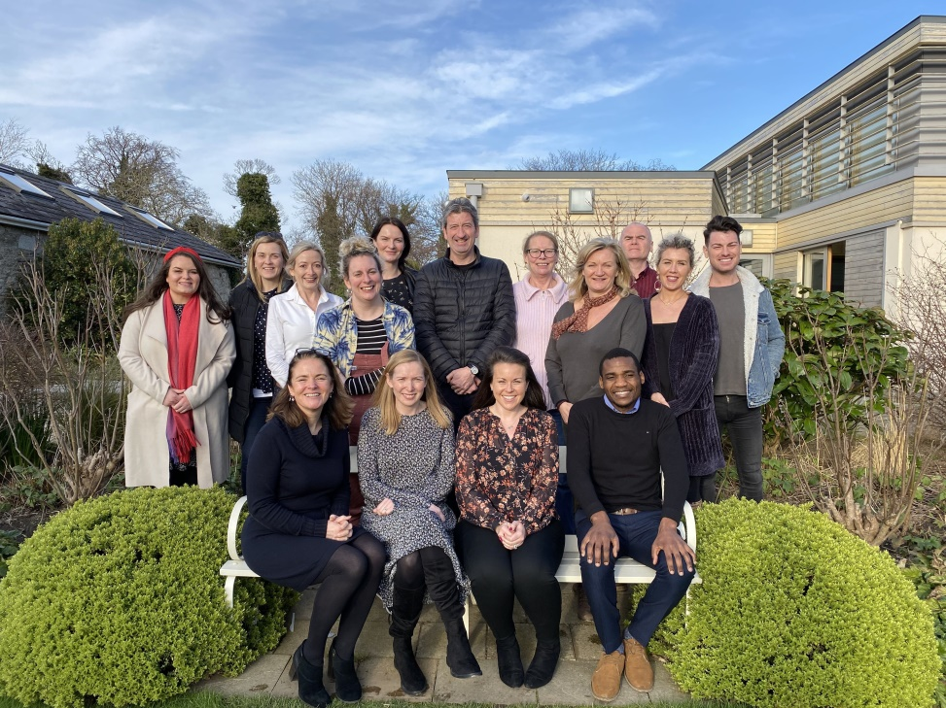

*The CDI Team in 2019*

# CDI Programmes

# ATTI

### Level of Activity in 2019

* The ATTI Steering Group had a very productive year with excellent engagement and participation at the eight steering group meetings held in 2019.
* A Breastival event was held on the 2nd October in the Civic Centre, Tallaght. It was a very successful event with approximately 40 mothers attending and participating in a range of workshops on bonding, weaning and infant development. Breastival is an initiative held in a number of locations around the country to promote and normalise breastfeeding among expectant and new mothers.
* The Solihull Foundation Course was delivered in October to thirteen professionals across a number of disciplines including Speech and Language, Early Years, Family Support and Psychology. The Solihull Approach aims to enhance the emotional health and wellbeing of children and families by facilitating an understanding of relationships, trauma and adverse childhood experiences and how to apply this understanding when intervening in family or personal difficulties.
* Thirteen participants also completed the Solihull Train the Trainer Course in November 2019. This will facilitate the growth and development of the Solihull Approach being applied to all disciplines working with children and families in Tallaght.

### Achievements and Outcomes in 2019

* The membership of the ATTI Steering Group was broadened and expanded during 2019 to reflect key objectives of ATTI .
* The Tallaght Welcomes Breast Feeding (TWBF) working group were invited to Áras an Uachtaráin to celebrate National Breastfeeding week and in recognition of the initiative’s work to increase rates of breastfeeding and supports available to new mothers.
* The TWBF Initiative was shortlisted for an Irish Healthcare Centre Award
* A range of TWBF materials were developed leading to increased visibility of the initiative in the community.
* Increased collaboration and engagement with fathers through the CEO of ‘From Lads to Dads’ joining the ATTI Steering Group.
* The ATTI Steering Group coordinated the screening of ‘Resilience’, a documentary exploring the long term impact of toxic stress and adverse experiences on children. A lively panel discussion followed the screening and over 100 professionals from a range of agencies attended the event. The event provided an excellent opportunity to deepen knowledge on infant mental health and relational trauma.
* ATTI was part of a Prevention and Early Intervention Network (PEIN) working group which collaboratively produced a position paper on Adverse Childhood Experiences (ACEs) and their long term impact on child development and links to adult outcomes.
* An abstract was accepted by and presented at the Institute of Public Health Conference, Belfast, November 2019. The poster presentation outlined the role of ATTI in coordinating a multi-agency approach in Tallaght.
* ATTI also participated in the All Ireland 2020 Maternity and Midwifery Festival with a facilitated workshop Together is Stronger – The Ante Natal to Three Initiative.

### Targets for 2020

* Continue to grow and broaden the membership of the ATTI Steering Group with a specific focus on extending its reach in the community.
* Rollout the Solihull approach to multi-agency Tallaght-based professionals working with parents, children and families. Achieving a critical mass of professionals trained and actively applying the approach will underpin engagement with and support of families. Integration of the Solihull Approach will lead to greater awareness of infant mental health and the emotional health and wellbeing needs of children and families.
* Facilitate Solihull Communities of Practice to ensure the Solihull approach is fully integrated as a way of working with families. Community of Practice meetings aim to foster expertise and confidence in the use of the Solihull Approach and to provide a supportive environment to help embed a multi-agency approach.
* Provide an Infant Mental Health Masterclass in collaboration with facilitators from Young Knocknaheeny with the objective of increasing Infant Mental Health Network participation to ensure continued awareness of Infant Mental Health and the importance of interventions in the child’s first 1000 days.
* Develop a social media campaign for Infant Mental Awareness week in early June to raise awareness of the role of early relationships and experiences.
* Continue to develop TWBF materials including Grandparent support materials to increase the range and levels of support available for new mothers facilitating an increase in the numbers choosing to breastfeed.
* Broaden the number of businesses supporting and engaging with the TWBF initiative by 20% to increase awareness of the benefits of breastfeeding
* Establish Breastival as an annual breastfeeding awareness and support event in Tallaght and coordinate the Breastival 2020 event

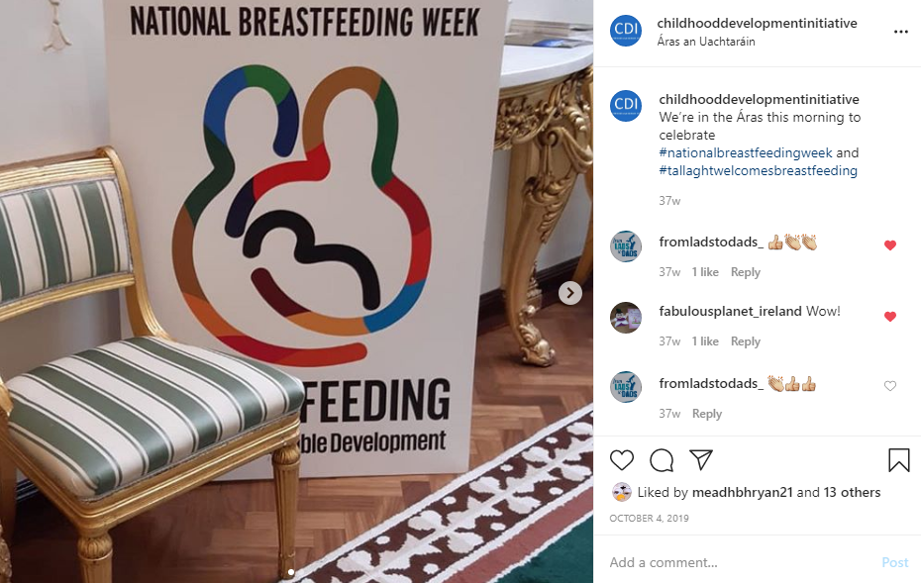  
*An Instagram post taken during Emma’s visit to Áras an Uachtaráin to celebrate National Breastfeeding week*

# Parental Support

# Parent Carer Facilitator

### Level of Activity in 2019

2019 saw our Parenting Specialist Elaine Fagan go on maternity leave and we were delighted to welcome Celine Moran to cover this post so that CDI could continue to support the Parent Carer Facilitators (PCFs) in offering parental supports in early learning and care services.

We said goodbye to Glynis Dunne, Caroline Moore and Emily Dunleavy, three of our PCFs who moved on to pastures new. This created an opportunity to reenergise the team and so far we have welcomed Elisabet Garcia and we look forward to welcoming another three new PCFs in 2020.

In 2019 we also said a fond goodbye to two Early Learning and Care services who received CDI’s parental supports over a number of years. This has created an opportunity to offer our parental supports to two new services in the Jobstown area and we look forward to seeing what next year brings in this regard.

In 2019 CDI worked in collaboration with the University of Limerick to develop our Parental Engagement and Relationships (PEAR) training package which is now ready to be rolled out to Early Learning and Care (ELC) services in Tallaght and beyond. CDI have also delivered a PEAR train the trainer programme and have trained facilitators now ready to deliver this programme.

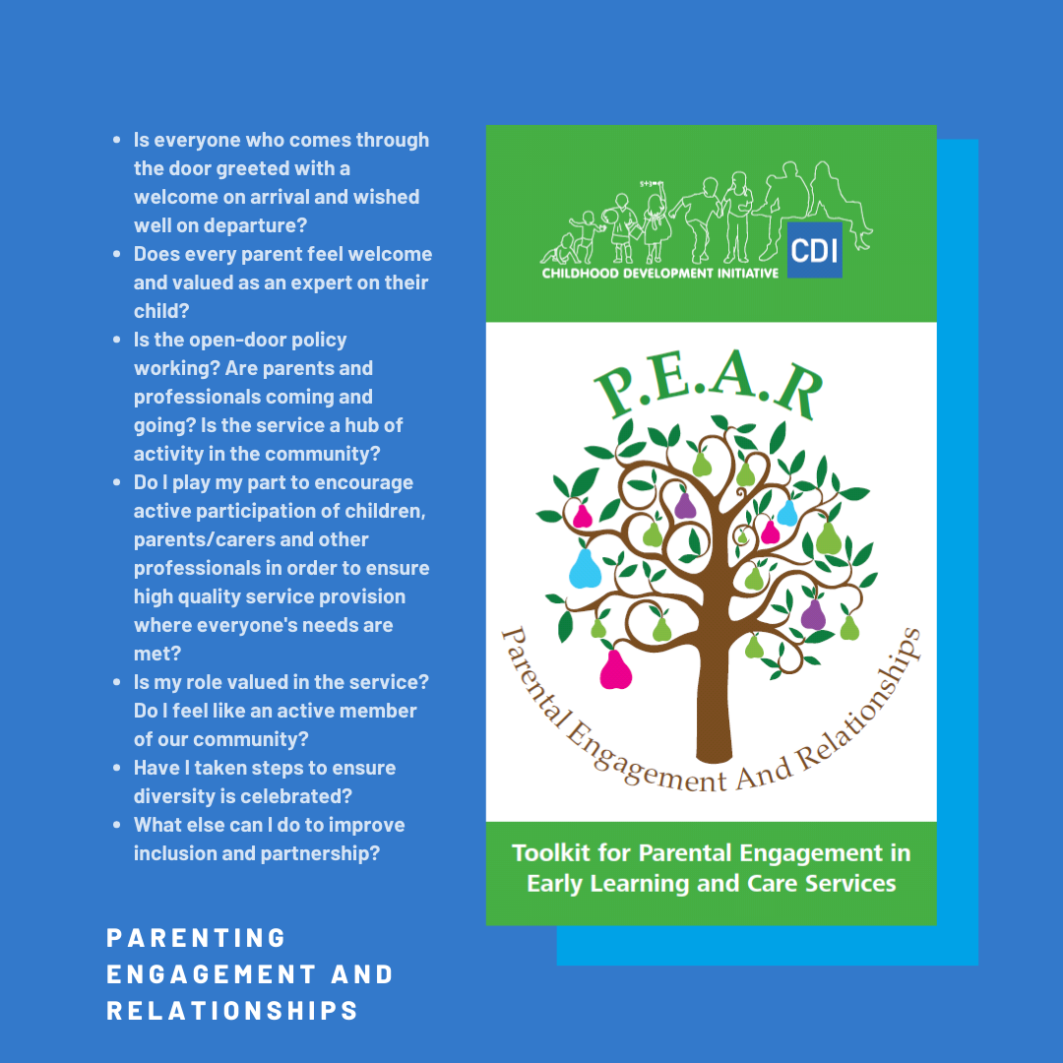

*A graphic demonstrating some of the ideas in our PEAR workbook*

### Achievements and Outcomes in 2019

* A total of 191 families were supported by the PCFs. Of these families 73% were mothers, 22% fathers and 5% other such as grandparents and foster parents.
* The PCFs completed 20 home visits to families in the community offering a range of targeted supports such as assisting parents to implement mealtime and bedtime routines and offering strategies to manage challenging behaviour in the home environment.
* The PCFs facilitated 11 Parents Plus courses in a range of locations in the Tallaght area. 21 mothers, one father and two grandparents successfully completed the programme.
* Collectively the PCFs facilitated 35 informal coffee mornings and 25 themed coffee mornings with a facilitator speaking on a specific topic e.g. Speech and Language Development, Dental Hygiene, ‘Minding your mental health’, to name but a few.
* Collectively the PCFs facilitated 308 one to one meetings with parents offering support with referrals.
* PCFs offered 55 parent and toddler group sessions to parents and children in ELCs in the community. The purpose of the parent and toddler groups is to create a welcoming space in the community for parents and their children where they can socialise, play and learn in a child friendly environment. Many of the children from the parent and toddler groups go on to attend the ELC setting thus enabling a positive transition, and creating an opportunity for early intervention as parents can become familiar with the setting and begin to develop relationships with the PCF.
* The PCFs facilitated 11 family events and outings during the year, for example, Christmas parties and outings to the farm/zoo. The primary aim of the family events is to create a social space whereby children and parents can enjoy quality time together in a relaxed environment. CDI’s parental supports have been demonstrated to reduce stress, improve relationships between parents and their children and build parental capacity.
* 100% of parents surveyed rated the quality of the parental supports offered by the PCF as being very good or excellent.
* Excellent attendance at PCF Communities of Practice (CoPs) throughout the year.

### Targets for 2020

* Continue to provide parental supports in eight ELC services in the Tallaght area.
* CDI have secured a prestigious Marie Sklodowska – Curie Actions (MSCA) grant allowing us to have a full time researcher, Dr Catarina Leitao, join the CDI team for a period of two years. This project will commence in May 2020 and will focus on evaluating our Parental Supports in Early Years looking at: the relationship between the ELC service and the parent, and parental engagement in children’s learning, focusing on areas such as home learning environment and school readiness. There will also be scope to review promising practice and evaluate fathers/co-parents participation in CDI’s model.
* Increase awareness of CDI’s PEAR toolkit within the ELC sector by disseminating information to a wider audience.
* Coordinate the roll out of PEAR training. Three pilot sessions to be delivered to an audience of 12 participants per training session... By hitting this target it is envisaged that at least 36 Early Learning and Care practitioners will be reached by the end of 2020
* All PCFs to conduct at least two home visits per month with targeted families in the community with a view to building parental capacity and improving the home learning environment. This will equate to the PCFs collectively conducting at least 112 home visits by the end of 2020
* Explore new ways to engage with more fathers through the parental support service. PCFs to facilitate two initiatives to engage fathers in their ELC setting during 2020
* Ensure the three new PCFs complete Parents Plus training with a view to delivering the programme in the community
* Increase our social media presence in relation to parental supports
* Coordinate the reestablishment of the local Parenting Forum i.e. co-ordinating a network of professionals delivering parental supports in the community with a view to sharing resources, prevent duplication etc.
* Re-energise and maximise the use of the PCF portal
* Pilot two new PCFs being employed and line managed directly by CDI;
* Facilitate six PCF CoPs and one PCF team building day in 2020. The aim of the PCF CoPs is to create a supportive space for PCFs to come together to share their knowledge and learning and to build their confidence and capacity through reflective practice ;
* Conduct at least two site visits to each ELC service in 2020 to monitor fidelity of parental supports offered;
* Every PCF to develop their own CPD plan for 2020 and report back to CDI on their activities in relation to CPD.

## Families Impacted by Prison

### Level of Activity in 2019

CDI was allocated a grant from Tusla to develop identify the needs of and improve understanding in relation to supporting men leaving prison to reintegrate with their **fam**ilies. Researchers were commissioned to undertake this work and interim and final reports were provided to the Research Advisory Committee throughout the year. An additional grant was provided by Tusla mid-year to enable the development of training and programme resources and an interagency Advisory Group was established to oversee and guide this work.

### Achievements and Outcomes in 2019

Research was commissioned by CDI and concluded during the year, with a report being launched and gaining significant media attention. See the full report [here](https://www.cdi.ie/wp-content/uploads/2019/12/CDI-Prisoners-Returning-Home-min.pdf) In addition to the launch, a roundtable policy discussion was held with key stakeholders to support the progression of recommendations and increased understanding of the needs of families and prisoners during and after imprisonment.

### Targets for 2020

The training and programme materials will be completed in early 2020 and a dissemination and support plan will be developed and implemented. We will continue to engage in discussions and information sharing with stakeholders to progress the implementation of the recommendations from the research.

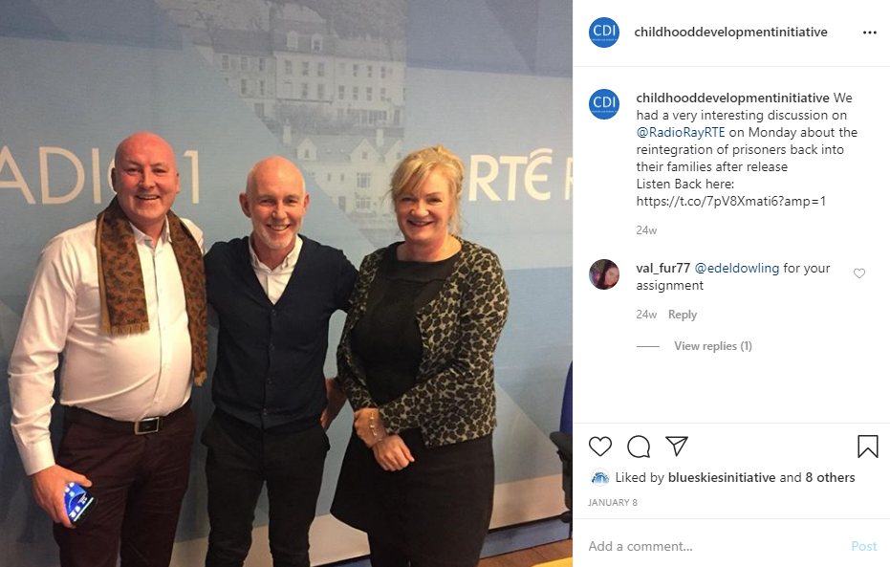

*Marian and James Bowes visit the Ray D’Arcy Show to discuss the Families Impacted by Prison*

# P:\Programmes\Chit Chat\PR&Communications\Logo\Email\Chit-Chat-logo.jpgChit Chat

### Level of Activity in 2019

2019 was an exciting year for Chit Chat which saw our team of two, grow to three! We were delighted to welcome Alison Butler to the Chit Chat team. Alison has a wealth of experience working with children, families and teachers for a number of years in a variety of settings across the UK.

Meadhbh Ryan, CDI’s social Media guru, we developed our social media presence in the form of Chit Chat Tuesdays. We rolled out our Chit Chat Champion initiative training Early Years Professionals and Teachers in our services. All of our services now have Chit Chat Champions in place; their role is to champion communication within their school and to implement various strategies and programmes. We would like to increase the number of Early Years services that we work with and commissioned a literature review to look at the evidence with regard to delivering services in the Early Years sector using a cycles approach. This review is expected in April 2020. We also commissioned a review and update of our online Summer Course for Primary School Teachers which will be delivered in Summer 2020.

* Therapeutic speech and language supports were offered in three DEIS primary schools and six Early Learning and Care (ELC) Services in Tallaght West.
* 31 children were on the caseload in January 2019, with 66 new referrals accepted. A total of 97 children accessed Chit Chat service in 2019.
* Our average waiting time from referral to initial assessment was 16 days.
* We had 82% attendance at initial assessment.
* 12 children were transferred to the HSE for continued intervention.
* 17 Coffee Mornings were held with 69 parents attending.
* 17 trainings were held with 94 teachers and Early Years’ professionals trained in how to create a communication friendly classroom environment, Chit Chat Champion training, Language land booster training, and training in milestones and detecting children who need onward referral.

### Achievements and Outcomes in 2019

* 94% of referrals were accepted in 2019, indicating that referrers are adequately trained in identifying children and referring appropriately to the Chit Chat service.
* 12 children were discharged Within Normal Limits following intervention in 2019.
* Three Chit Chat primary schools and five Chit Chat ELC Services have a communication champion in place.
* 100% of parents surveyed reported satisfaction with the service.
* 90% of parents surveyed reported a reduction in worry regarding their child’s communication following therapy.

### Targets for 2020

* Continued service delivery to three DEIS primary schools and six ELC Services in Tallaght.
* Deliver Online Summer Course to 75 Primary School Teachers ‘Supporting speech, Language and Communication in the Primary Classroom and Beyond’ in Summer 2020;
* Develop a Chit Chat Toolkit for Early Learning and Care Services and corresponding training;
* Complete Literature review of cycles approach to service delivery in the Early Years;
* Deliver ‘Communication Environment & Norms’ training, and refresher ‘Referrals Training’ to all 6 EY services and all 3 Primary Schools.
* Deliver booster Communication Champion Training to all sites.
* Offer three Hanen Teacher Talk trainings to 60 EY Professionals and 20 Primary School Teachers in Tallaght.
* Booster training for Language Land, our in class programme which supports the oral language development of children in the Early Years and Junior Infants to be rolled out to all Chit Chat sites.
* Weekly social media posts for Chit Chat Tuesdays’ on CDI’s social media platforms.

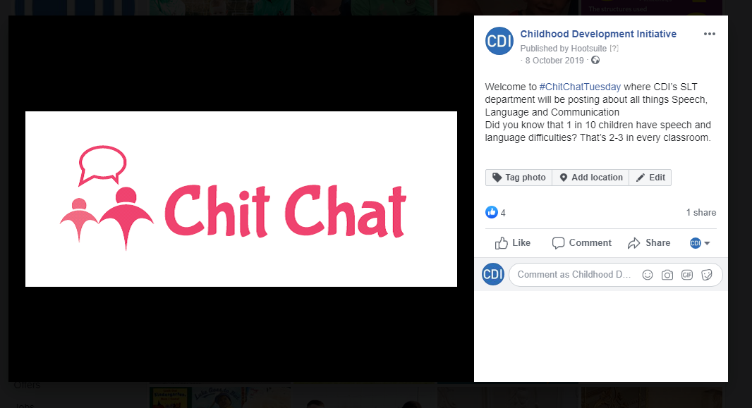

*Our first #ChitChatTuesday post*

# Doodle Den

### Level of Activity in 2019

2019 saw 16 schools deliver Doodle Den, eight in Tallaght and eight in Dublin 1 and 7, with approximately 234 children taking part in the programme. Each site participated in three COPs with three site visits per school completed.

### Achievements and Outcomes in 2019

There were significant gains in all elements of the programme with pre and post tests indicating a 97.9% improvement in Social Skills, 87.1% in Phonics Skills, 87.2% improvement in writing skills and 98.9% improvement in sight vocabulary skills. Parents and children reported positive attitudes and practices towards literacy and school with 98.1% of parents and 79.1% of children reporting positive practices and attitudes towards literacy.

### Targets for 2020

In 2020 we aim to continue working with the sites (16) delivering Doodle Den and hope to see an expansion of Doodle Den into Cork. This will include booster training, COPs and site visits to support quality and fidelity.

Q2 will see the finalisation of a literacy policy paper, extracting key messages from CDI research and evaluations and internal monitoring. A communications strategy will compliment this policy paper and target policy makers and decision makers with these key messages. A literacy conference will be held in 2020 to launch the paper and showcase some of the literacy work currently in action in Tallaght. An online training summer school will be developed to train Doodle Den facilitators. 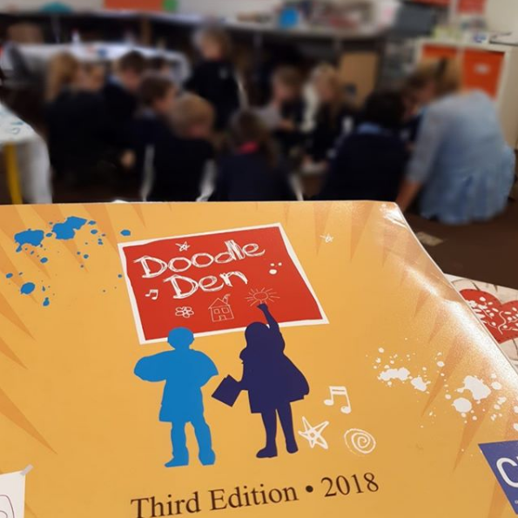

*A photo taken by one of our Doodle Den Facilitators during a session in 2019*

# Doodle Families



### Level of Activity in 2019

Doodle Families was facilitated in 17 schools in Tallaght, Mayo, Donegal, Limerick and Galway and attended by 246 children and their parents.

### Achievements and Outcomes in 2019

2019 saw the publication of *‘Literacy, Learning and Linkages: A process evaluation of the Doodle Families Programme’*. The outcomes of the research, both qualitative and quantitative, point to the positive impact of the Doodle Families Programme in increasing the effectiveness of school and community agencies working with families to develop children’s literacy the Final Report can be accessed [here.](https://www.cdi.ie/wp-content/uploads/2019/05/CDI-Literacy-Learning-and-Linkages-v4.pdf) Our own data also outlines achievements of outcomes in that both children and parents reporting positive attitudes and practices towards literacy.

### Targets for 2020

We are committed to continuing to support those delivering the programme and extend its provision to a wider range of schools.

We will develop an online summer school for training Doodle Families facilitators.

# Dolly Parton’s Imagination Library

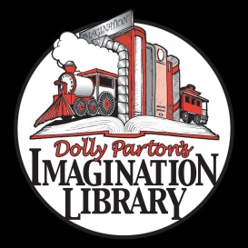

### Level of Activity in 2019

2019 saw the launch of DPIL in Tallaght and surpassing all targets;

4,400 children registered= 65% of the population of 0- 5 year old children in Tallaght;

33,108 books were delivered;

Approximately 1500 parents and children attended 2 large events in 2019, the launch on 14th Feb and a celebration of the success of the Imagination Library on the 18th October in Tallaght Library.

We established a research baseline for a cohort of just under 300 families looking at current literacy practices and home learning environments. 87.5% of respondents were the child’s mother with just under 8% of fathers responding to the survey. Of those just over 49% had an education at tertiary level with just fewer than 10% reporting highest level of education at either no formal education/primary school/ or junior certificate level.

Added value activities, i.e. regular emails with tips on reading, health and wellbeing as well as activities in the community saw engagement above the norm for the sector. Opening rates were between 36-80%.

There were 7 meetings of the of the DPIL advisory group who provided ongoing support and implementation of The Imagination Library.

### Achievements and Outcomes in 2019

We are the Irish affiliate of Imagination Library achieving phenomenal success in the first phase of the pilot in Dublin 24. Along with The Dollywood Foundation, we’re exploring how to expand the programme in Ireland.

There were significant social media interactions and coverage in national and local media including TV and radio.

We have had invaluable support from An Post, who have absorbed the cost of delivering the books for the first year and successfully negotiated their continued involvement in 2020, and have established a strong relationship with the Rotary Club, who has agreed to support us through fundraising for the programme.

Shamrock Rovers also played a role in securing excellent photo opportunities for the launch the Imagination Library. We look forward to growing this relationship in 2020.

### Targets for 2020

* Maintain and continue to establish relationships with local businesses and agencies in Tallaght, for the purposes of ensuring all children avail of the programme but also to support The Imagination Library through fundraising.
* Continue to deliver high quality books to children in Dublin 24 and reach 75% of the population.
* Develop effective mechanisms to engage hard-to-reach and vulnerable groups.
* Maintain monthly contact with families registered with DPIL providing them with added value activities in the form of emails, and social media contacts and activities in the library.
* Establish a parent ambassador fundraising group.
* Maintain and continue monitoring and evaluation practices through research to establish the impact of receiving the books for children and families over the lifetime of the pilot.
* Develop an implementation guide, structures and a Memorandum of Understanding for those wishing to partner with CDI the Irish affiliate for DPIL.
* Expand to Cork through Young Knocknaheeny and Limerick.
* Host another family fun day in collaboration with local partnerships and sponsors.

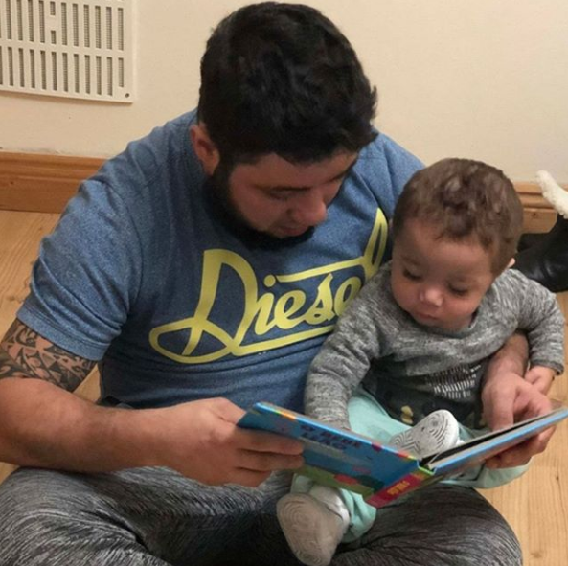 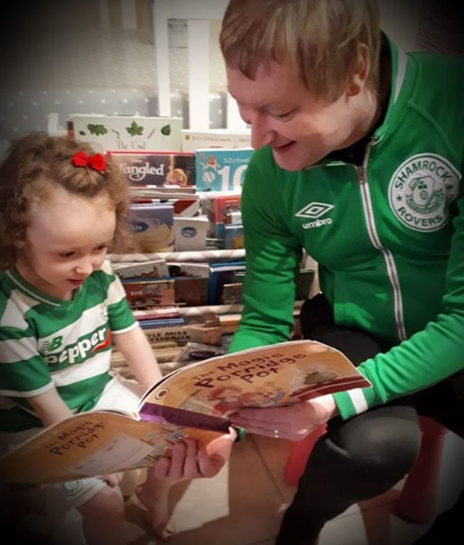 *Some of the entries to our Shamrock Rovers Mascot competition*

# Restorative Practices

### Level of Activity in 2019

2019 was an exciting and busy year for Restorative Practices (RP) with lots of developments and achievements!

Our delivery of RP Training around the country continued to grow and this growth was made possible by the expansion of CDI’s RP Training Panel when a new group of RP Trainers graduated in March 2019. We continued to innovate when our first Restorative Practices Champions course, which trained experienced CDI RP Trainers to deliver our Training of RP Trainers course, was delivered in July. We also developed our provision of ongoing Continual Professional Development (CPD) for RP Trainers with two full day events in February and November 2019.

We continued to develop key partnerships with the [Professional Development Service for Teachers](https://www.pdst.ie/) (PDST), [Oberstown Children Detention Campus](https://www.oberstown.com/) and [Restorative Practices Ireland](http://www.restorativepracticesireland.ie/) in order to support the growth of RP across the island of Ireland. We made progress on the EU Erasmus+ project, [TReP](https://www.cdi.ie/erasmus/) (Professional Training in Restorative Practices), which is a three year project that began in September 2018. The project is working to create and test a part-time online training course in Restorative Practices for an [EQF](https://www.cedefop.europa.eu/en/events-and-projects/projects/european-qualifications-framework-eqf) Level 5 ([NFQ](https://www.qqi.ie/Articles/Pages/National-Framework-of-Qualifications-(NFQ).aspx) Level 6) Undergraduate Certificate. We were very happy to welcome our TReP partners to CDI for a week of RP Training in June.

A big change occurred at the end of May 2019 when we sadly parted ways with [Linda Mullally](https://www.linkedin.com/in/linda-mullally-538b8989/?originalSubdomain=ie), who happily went on to bigger and better things. Claire Casey became RP Programme Manager and we were delighted to welcome George Best to the CDI team in September as our full time RP Programme Coordinator. In the virtual world, Restorative Practices became more active on social media, with a weekly posting each Monday with up to date news, events and resources related to all things Restorative!

We had a very busy summer in 2019 with multiple Summer Courses for Teachers around the country and a marked increase in our provision of Training of RP Trainers (ToT) courses, from one per year in 2014, ‘15, ‘16 and ‘17, to three in 2018, and to six ToT courses being delivered in 2019. Our ToT courses are a core part of our work to build capacity for the delivery of RP Training in Ireland and provide support for the adoption of RP in key agencies and sectors across the country. Our own capacity to expand this work was further developed in 2019 by the recruitment of five additional [RP Associate Quality Specialists](https://www.cdi.ie/restorative-practices-quality-specialists/) to our Panel of Quality Specialists, bringing the RP Associate Quality Specialist Team to 13.

### Achievements and Outcomes in 2019

* Overall, a total of 879 participants attended and completed CDI’s Restorative Practices training in 2019, an increase of more than 300 participants as compared to or our delivery of RP Training to approximately 500 people in 2018.
* Throughout the year, we delivered 25 Getting Started with RP courses with 540 people completing our introductory training in 2019, and we delivered eight Restorative Practice Facilitation Skills courses upskilling 71 participants at venues across Ireland.
* Five RP Trainers Communities of Practice were facilitated during the year to support ongoing reflective practice and sharing of learning among RP trainers, with an average of 14 RP Trainers attending each session.
* A new CPD programme for RP trainers was launched with a workshop on Nonviolent Communication in February 2019, attended by 32 RP Trainers, and followed up by a reflective practice event in November called “Whither in RP” which looked at where RP had come from in Ireland and posed the question “where are we going over the next decade”? We were delighted to share the wisdom and experience of [Tim Chapman](https://www.linkedin.com/in/tim-chapman-54008814/), a friend to CDI and Chairperson of the [European Forum for Restorative Justice](https://www.euforumrj.org/en). We had a very interesting and empowering day and 23 RP Trainers attended.
* In February 2019 we published a research [Regional Report](https://www.cdi.ie/wp-content/uploads/2019/04/TReP-Restorative-Practices-Regional-Report.pdf) for our TReP project, which includes a summary on the history and use of restorative practices, and the level of RP training available in, the TReP partner countries of Malta, Ireland, Bulgaria, Spain and Germany.
* We had two graduation ceremonies for RP Trainers in March 2019. Nine people graduated as RP Trainers on the 2nd of March at the first ceremony in Carrigtwohill, their certificates were presented by Lord Mayor Fergal Dennehy. The Carrigtwohill group were so excited, they baked a cake! Five days later, on the 7th of March, 17 people graduated as RP Trainers at CDI, with Lord Mayor Charlie O’Connor doing the honours and presenting the trainers with their certificates.
* Between April and May 2019, Anti-violence Restorative Training (ART) was delivered to 40 young people at [Oberstown Children Detention Campus.](https://www.oberstown.com/)
* A successful pilot project of RP Training in Schools was completed with the [Professional Development Service for Teachers](https://www.pdst.ie/) (PDST) in May 2019. RP training was delivered to 25 schools all across the country by CDI RP Trainers assigned as Associates with the PDST between Sept 2018 and May 2019, and CDI provided the PDST with bespoke RP Training materials for this pilot project. The feedback from the pilot schools (13 primary and 12 post-primary schools took part) was sufficiently positive to enable the PDST to begin delivery of the training with a further 47 schools in the next academic term, from September 2019 to June 2020.
* Between May and September 2019, we delivered six Training of RP Trainers courses in venues across the country with 59 participants from nine counties (Cork, Dublin, Galway, Kildare, Laois, Meath, Westmeath, Waterford, and Wicklow) trained to be RP trainers
* Between July and August 2019, we delivered 12 RP Summer Courses for Teachers in schools and education centres across the country, in seven counties (Clare, Cork, Dublin, Kildare, Laois, Waterford and Wexford), with 168 participants taking part.
* Our first ever RP Champions Course too place in July 2019, and twenty RP Champions graduated in September 2019. CDI were delighted that Fr. Peter McVerry was there as our Guest of Honour to present them with their certificates.
* Between September and December 2019, 257 teachers in seven Munster schools engaged in CDI’s RP Training with the support of funding from the [Tomar Trust](https://tomartrust.org/) with the intention of becoming fully restorative schools.
* In October 2019, CDI commissioned an external evaluation on our Restorative Practices training courses. We are again breaking new ground by conducting the first impact study of RP Training in Ireland. The external consultant began contacting people six to eight months after they had undertaken CDI’s RP training to find out whether or not the training has changed their personal interactions or work practices. The report is due to be finalised by summer 2020, and we are eagerly awaiting the results!
* In November 2019, CDI’s RP programme began a project to compile case studies of people in Ireland working with and using RP in their professional and personal lives. Dorothée Potter Daniau, an RP Quality Specialist with CDI (and Coordinator of the [Alternatives to Violence Project Ireland](http://avpireland.ie/)), began conducting a series of recorded interviews with people from all across Ireland who are sharing their experiences of using Restorative Practices daily. The interviews will form a Podcast series to be launched in April 2020 that is entitled “*Circles of Connection: Stories from Ireland about Using Restorative Practices to Build Relationships.* “
* Restorative Practices Programme Manager, Claire Casey, graduated from Ulster University in December 2019 with a distinction for her Masters in Restorative Practices!

### Targets for 2020

* Publish and disseminate the independent evaluation of our RP Training provision and implement any recommendations arising.
* Publish and disseminate a new RP training brochure to engage and work with small local businesses in Tallaght to further our work of supporting Tallaght to become a restorative community.
* Launch the RP podcast series (12 podcasts) and publish 20 written case studies from interviews in April, and promote both online.
* Continue RP weekly presence on all CDI’s social media sites advertising and promoting all things RP.
* Deliver at least 16 Getting Started with RP courses to 256 participants in 12 counties.
* Deliver at least six Restorative Practice Facilitation Skills courses to 96 participants in eight counties.
* Deliver at least 14 Summer Courses to 224 participants in schools and Education Centres across Ireland (in at least eight counties).
* Deliver at least Four Training of Trainers courses to 40 participants in at least 3 counties.
* Develop online Erasmus+ TReP online course content and begin pilot delivery of the course in September.
* Deliver two RP Trainers Continuing Professional Development events in April and November.
* Facilitate ten RP Trainers Communities of Practices to ensure support and high quality standard RP training across Ireland.
* Develop two RP Junior Cycle Learning Units for the Wellbeing programme and deliver both in 30 post-primary schools from September to December.
* Graduate 72 2018 and 2019 trainees as RP Trainers in May.
* Establish a legally independent membership-based national network to promote and support High quality Restorative Practices across the country in conjunction with Restorative Practices Ireland by December 2020.
* Establish a partnership with an Education and Training Board to develop an RP Training Programme at Level Six on the [National Framework of Qualifications](https://nfq.qqi.ie/) for validation and accreditation by [Quality and Qualifications Ireland](https://www.qqi.ie/) by June 2020.
* Pilot delivery of QQI Level Six accredited RP Training course for at least 12 participants between September and December 2020.
* Develop RP modules for two Teacher Training courses by December 2020.
* Support the PDST to upscale their RP Training delivery by training PDST RP Champions in July 2020.
* Support Oberstown Children Detention Campus to become a restorative organisation by skilling staff to facilitate RP Communities of Practices on Campus.

# Emerging Needs

### Level of Activity in 2019

In line with CDI's commitment to identifying and responding to new and emerging needs, CDI progressed a number of developments during 2019. The continued adaptation of our work with families impacted by prison have been outlined above. In addition, we undertook the following:

* **Housing Research**: In 2019, we published a significant report which included a review of three previous CDI studies and a broad range of key national and local data. The report sought to examine, using retrospective data spanning almost twenty years, whether or not Tallaght is a positive place to live.
* **In-betweeners Research**: A multi-agency group, led by CDI, identified the unmet mental health needs of young people in Tallaght. A study was commissioned by CDI to quantify and understand these needs, through consultation with parents and service providers. Subsequent to the publication of this report, a literature review on models of existing practice was commissioned, and an interdisciplinary group of key stakeholders was supported to participate in a study visit to an online youth mental health service in Malta.
* **Experiences of Families in Homelessness**: On behalf of South Dublin Children and Young Persons Committee (CYPSC), CDI commissioned research to be undertaken with parents who have experienced homelessness, and frontline services working with them. The consultation process utilised the ‘Photovoice’ methodology, in which participants use images to articulate their experience. The report was launched by Minister Katherine Zappone and received considerable media attention, locally and nationally. CDI chairs the CYPSC subcommittee which supported the research and is now implementing the recommendations from the report.

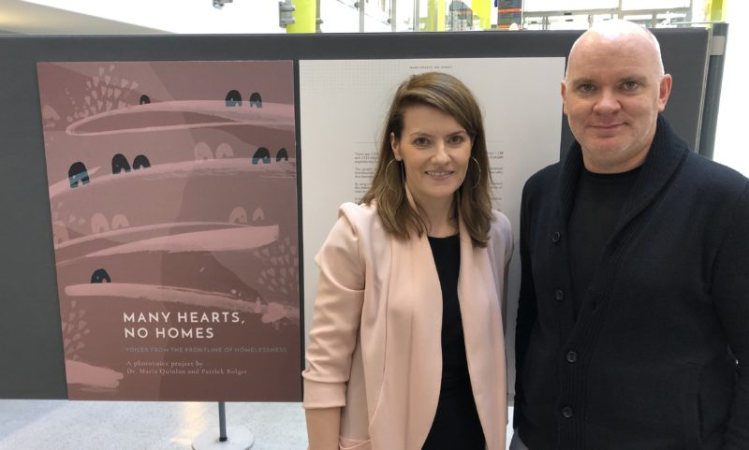

*Dr Maria Quinlan and Patrick Bolger at the launch of “Many Hearts, No Homes”*

### Achievements and Outcomes in 2019

Each of the above reports were widely disseminated and achieved considerable media engagement as well as interest from policy makers, researchers and service providers.

The interagency nature of the reports on homelessness and youth mental health were important aspects of both the research process and the subsequent engagement with the findings.

CDI obtained funding from the HSE to provide laundry facilities to a local Family Resource Centre for those living in hotels. An app has also been commissioned to enable families to readily identify local supports, which is particularly important for those who are ‘self accommodating’ and therefore moving frequently.

In December 2019, CDI coordinated a Christmas party for approximately 80 parents and children living in homelessness. Hosted by Citywide Education, and supported by Focus Ireland and other local services, this offered the children an opportunity to engage in traditional games and activities, and parents some space to themselves and to socialise.

### Targets for 2020

CDI will continue to engage with policy makers and service providers to share the learning from our work, and to influence future policy planning and service delivery.

In relation to youth mental health, the following will also be progressed during 2020:

* A systematic review of literature on existing models of intervention for the identified cohort of young people with mental health difficulties will be completed
* The Advisory Group will continue to meet and shape the project
* 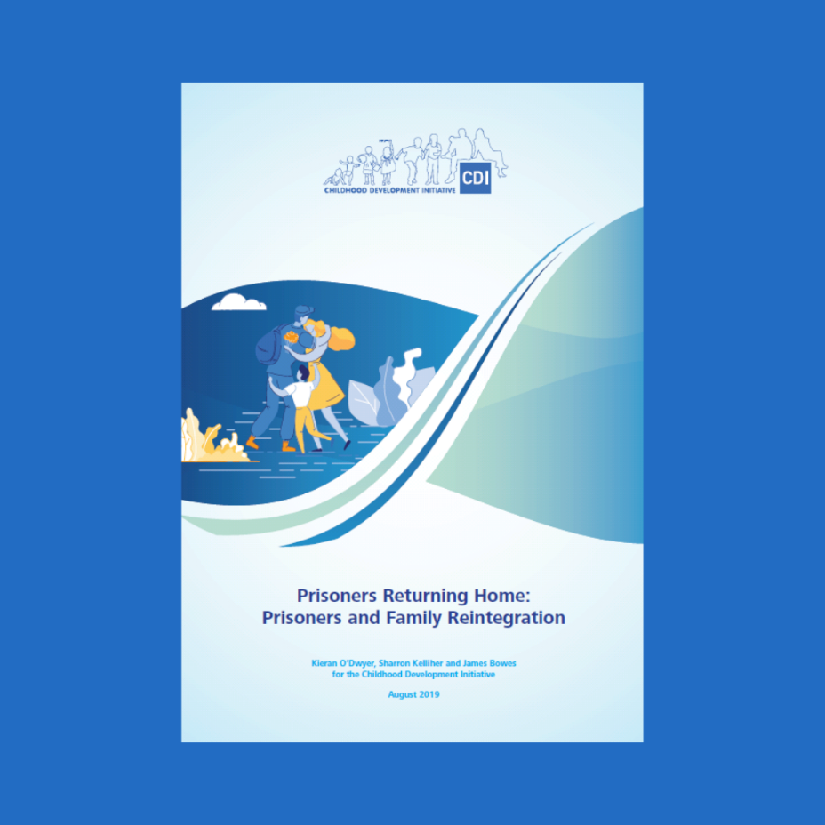Funding will be sought to deliver a pilot intervention, based on the literature review.

*The cover of the Prisoners Report*

# Planning, Monitoring and Evaluation (PM&E)

### Achievements and Outcomes in 2019

In 2019, CDI continued to consolidate and strengthen its internal PM&E system. Particular progress was made in completing M&E plans for each programme area, improving tool and data quality, programme targeting and staff capacity. A number of discrete evaluation or research projects supported the use of data for learning and programme improvement. CDI also played an important role in design and development of the wider Tusla ABC programme outcomes framework.

* **Programme M&E planning:**
  + All programme leads were supported to finalise their M&E plans, including defining indicators, tools and targets for their expected outcomes by 2020;
  + Due to quality and consistency issues in existing data, a phased approach was taken to building capacity at each of the stages of data collection, beginning with tool review and refinement. Over 20 tools were refined in advance of the 2019/2020 academic year. All tools must now go through a quality check in advance of sending out;
  + The next phase was a review of data quality and entry and analysis. A systematic analysis of data, where available, across indicators in the M&E plans was undertaken to inform learning and reporting.
* **Programme Implementation Planning:** CDI’s programme planning system was adapted to improve accountability to, and alignment with, business plan targets and Monitoring and Evaluation Plans.
* **Targeting:**
  + A systematic review of secondary data on deprivation and disadvantage was undertaken to inform programme targeting on an ongoing basis. This data forms the basis of a more in-depth look at child poverty in 2020 to underpin the CDI Strategic Planning process;
  + Where possible, population data questions were added to tools based on interaction with disadvantage, such as ethnicity and gender.
* **Internal capacity:**
  + The part time Data Officer position was extended to a full-time Data Specialist role, supported by the Business Development Manager.
  + An internal training for staff was held in April 2019, while programme staff attended CDI’s QSBO Logic Modelling and M&E training in December.
  + One-to-one support is provided to programme teams to develop M&E plans, and review tools and data collection and management processes.
* **Information Management System**: An improved shared online information and data storage system was rolled out.
* **M&E Outputs:** The following policy papers and evaluation/ research reports were developed and published:
  + [The In-Betweeners: Identifying and quantifying the unmet mental health needs of children and adolescents in Tallaght](https://www.cdi.ie/wp-content/uploads/2019/12/The-Inbetweeners-Report-web.pdf)
  + [Prisoners Returning Home: Prisoners and Family Reintegration Project](https://www.cdi.ie/wp-content/uploads/2019/12/CDI-Prisoners-Returning-Home-min.pdf)
  + [Housing Policy Development Lessons – A Tallaght West Case Study, 2019](https://www.cdi.ie/wp-content/uploads/2019/06/CDI-Final-Housing-Report-08.04-web.pdf)
  + [Housing Policy Development Lessons – Executive Summary, 2019](https://www.cdi.ie/wp-content/uploads/2019/06/CDI-Housing-Policy-Summary-v3.pdf)
  + [Many Hearts, No Homes: Voice from the Frontline of Homelessness. A Photovoice project by Dr. Maria Quinlan and Patrick Bolger](https://www.cdi.ie/wp-content/uploads/2019/08/MHNH-Report-lowres-28.3.pdf), 2019
  + [Ante Natal to Three Initiative Policy Brief, 2019](https://www.cdi.ie/wp-content/uploads/2019/03/CDI-ATTI-Policy-Brief-Mar19-web.pdf)

### Targets for 2020

**The priorities for CDI’s Planning, Monitoring& Evaluation system for 2020 include:**

* Internal system strengthening: Progressively strengthening staff capacity, particularly in using data for reporting and planning, development of data collection tools, and data analysis and visualisation.
* Implementing and reviewing new programme planning system
* Information management system strengthening: Building on the revised shared drive, focused on the development of online systems for data management.
* Deepening understanding of child poverty in context by conducting a contextual analysis of child poverty and using the findings to inform CDI’s strategic planning process in 2020.
* Contribute to external monitoring and evaluation processes within Tusla, the ABC programme and other partners working to improve outcomes for children.

# CDI Training and Consultancy Service:

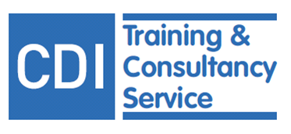

### Level of Activity in 2019

CDI’s social enterprise continued to develop in line with the CDI Business Development Plan 2018-2021. The primary offerings within the service in 2019 were RP training and the Quality Services, Better Outcomes (QSBO) training, in addition to ongoing and new consultancy projects.

### Achievements and Outcomes in 2019

**RP Training**: RP training reached 879 people in 2019. Please see section 7 above for more detail.

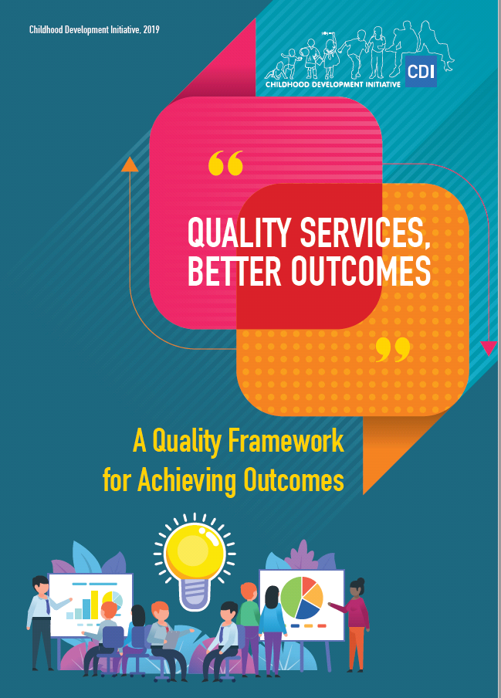

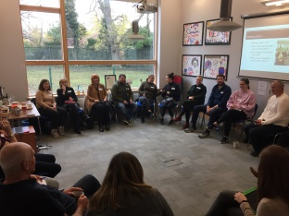

RP Training at CDI November 2019

**QSBO:** The revised QSBO Workbook - a holistic quality toolkit aiming to improve the practice and impact of services - was published with an additional focus on implementation science and new chapters dedicated to PM&E, and reflective practice. The accompanying 9-course training series was launched in June. Based on a costed business plan and using CDI’s online booking system, three course modules within the accompanying training series were delivered, reaching 48 participants. Courses delivered included two introductory courses, one Logic Modelling course and one Planning, Monitoring and Evaluation course.

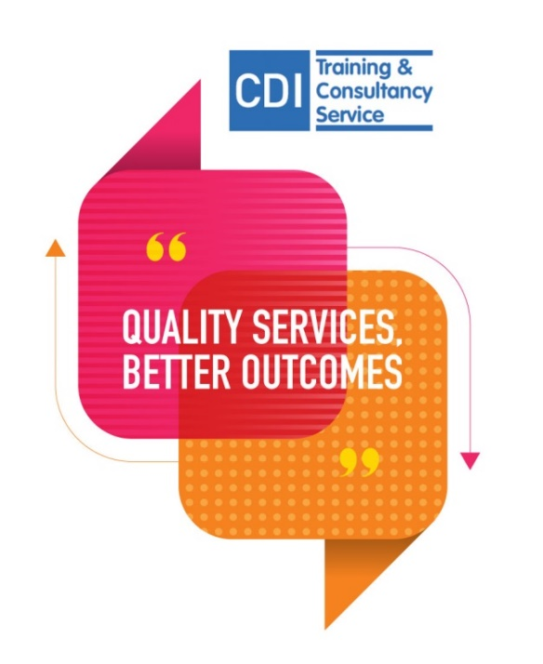

Feedback from the courses is overwhelmingly positive with overall participants being highly satisfied across a range of criteria, with particularly high scores given to trainer expertise. Examples of feedback in 2019 includes:

*‘Great format – interactive and engaging training’* Community Development Manager

*‘Very well planned and well presented’* Health Practitioner

*‘Can see this process as being very effective to reach goals- small or large’* Early Learning and Care Practitioner.

*‘Good mix of theory and practical tasks’* Community Development Worker.

Consultancy projects were also undertaken with the following clients: Oberstown Children Detention Campus – RP training and supports; UCD School of Education – provision of lecture series; An Cosán – Mentoring, the Professional Development Service for Teachers, – RP training and supports; the Irish Association for Social Inclusion Opportunities – RP support;and the Community Addiction Response Project – RP training.

Marketing and branding guidelines were created for the social enterprise which also initiated a change in name from QuEST to CDI Training and Consultancy Service, while a marketing campaign was designed to promote the 2020 QSBO training schedule.

### Targets for 2020

* Develop/update costed business plans for RP Training, Doodle Den and Doodle Families trainings, Chit Chat online training and PEAR (Parental Engagement and Relationship) Training;
* Deliver 9 QSBO training courses and develop at least one strategic partnership with established training organisations and platforms;
* Grow consultancy partnerships and contracts, particularly related to QSBO- Monitoring and evaluation, Logic Modelling and Reflective Practice.

# Conclusion

CDI’s 2019 Annual Report provides data on levels of activity, numbers of children and families reached, and on the range of services provided. It also names the research completed during the year, identifies the key issues and challenges, and indicates plans for the future and specific targets for 2020.

Undoubtedly service delivery will be seriously interrupted in the year ahead, as the realities of life with Covid-19 become apparent. Whilst we do not yet know the full implications for our services or communities we work with, we can be confident that all at CDI will utilise the creativity, hard work and professionalism which underpin our approach to be responsive and relevant in whatever the future brings.

# Acronyms

ACEs Adverse Childhood Experiences

AVP [Alternatives to Violence Project Ireland](http://avpireland.ie/)

ART Anti-violence Restorative Training

ATTI Antenatal to Three Initiative

CoPs Community of Practice

DPIL Dolly Parton Imagination Library

ELC Early Learning and Care

EY Early Years

EIQH Excellence Ireland Quality Association

MSCA Marie Sklodowska Curie Actions

M&E Monitoring and Evaluation

PCF Parent Carer Facilitator

PEAR Parental Engagement and Relationships

PEIN Prevention and Early Intervention Network

PM&E Planning, Monitoring and Evaluation

PDST [Professional Development Service for Teachers](https://www.pdst.ie/)

QS Quality Specialist

QSBO Quality Services Better Outcomes

RP Restorative Practices

RPI Restorative Practices Ireland

CYPSC South Dublin Children and Young Persons Committee

SORP Statement of Recommended Practice

TOT Training of Trainers

TWBF Tallaght Welcomes Breastfeeding

Contact Us:

[info@cdi.ie](mailto:info@cdi.ie)

[twitter.com/twcdi](http://www.twitter.com/twcdi)

[instagram.com/childhooddevelopmentinitiative](http://www.Instagram.com/childhooddevelopmentinitiative)

[facebook.com/childhooddevelopmentinitiative](http://www.facebook.com/childhooddevelopmentinitiative)

[linkedin.com/childhooddevelopmentinitiative](https://www.linkedin.com/company/twcdi.ie/)

